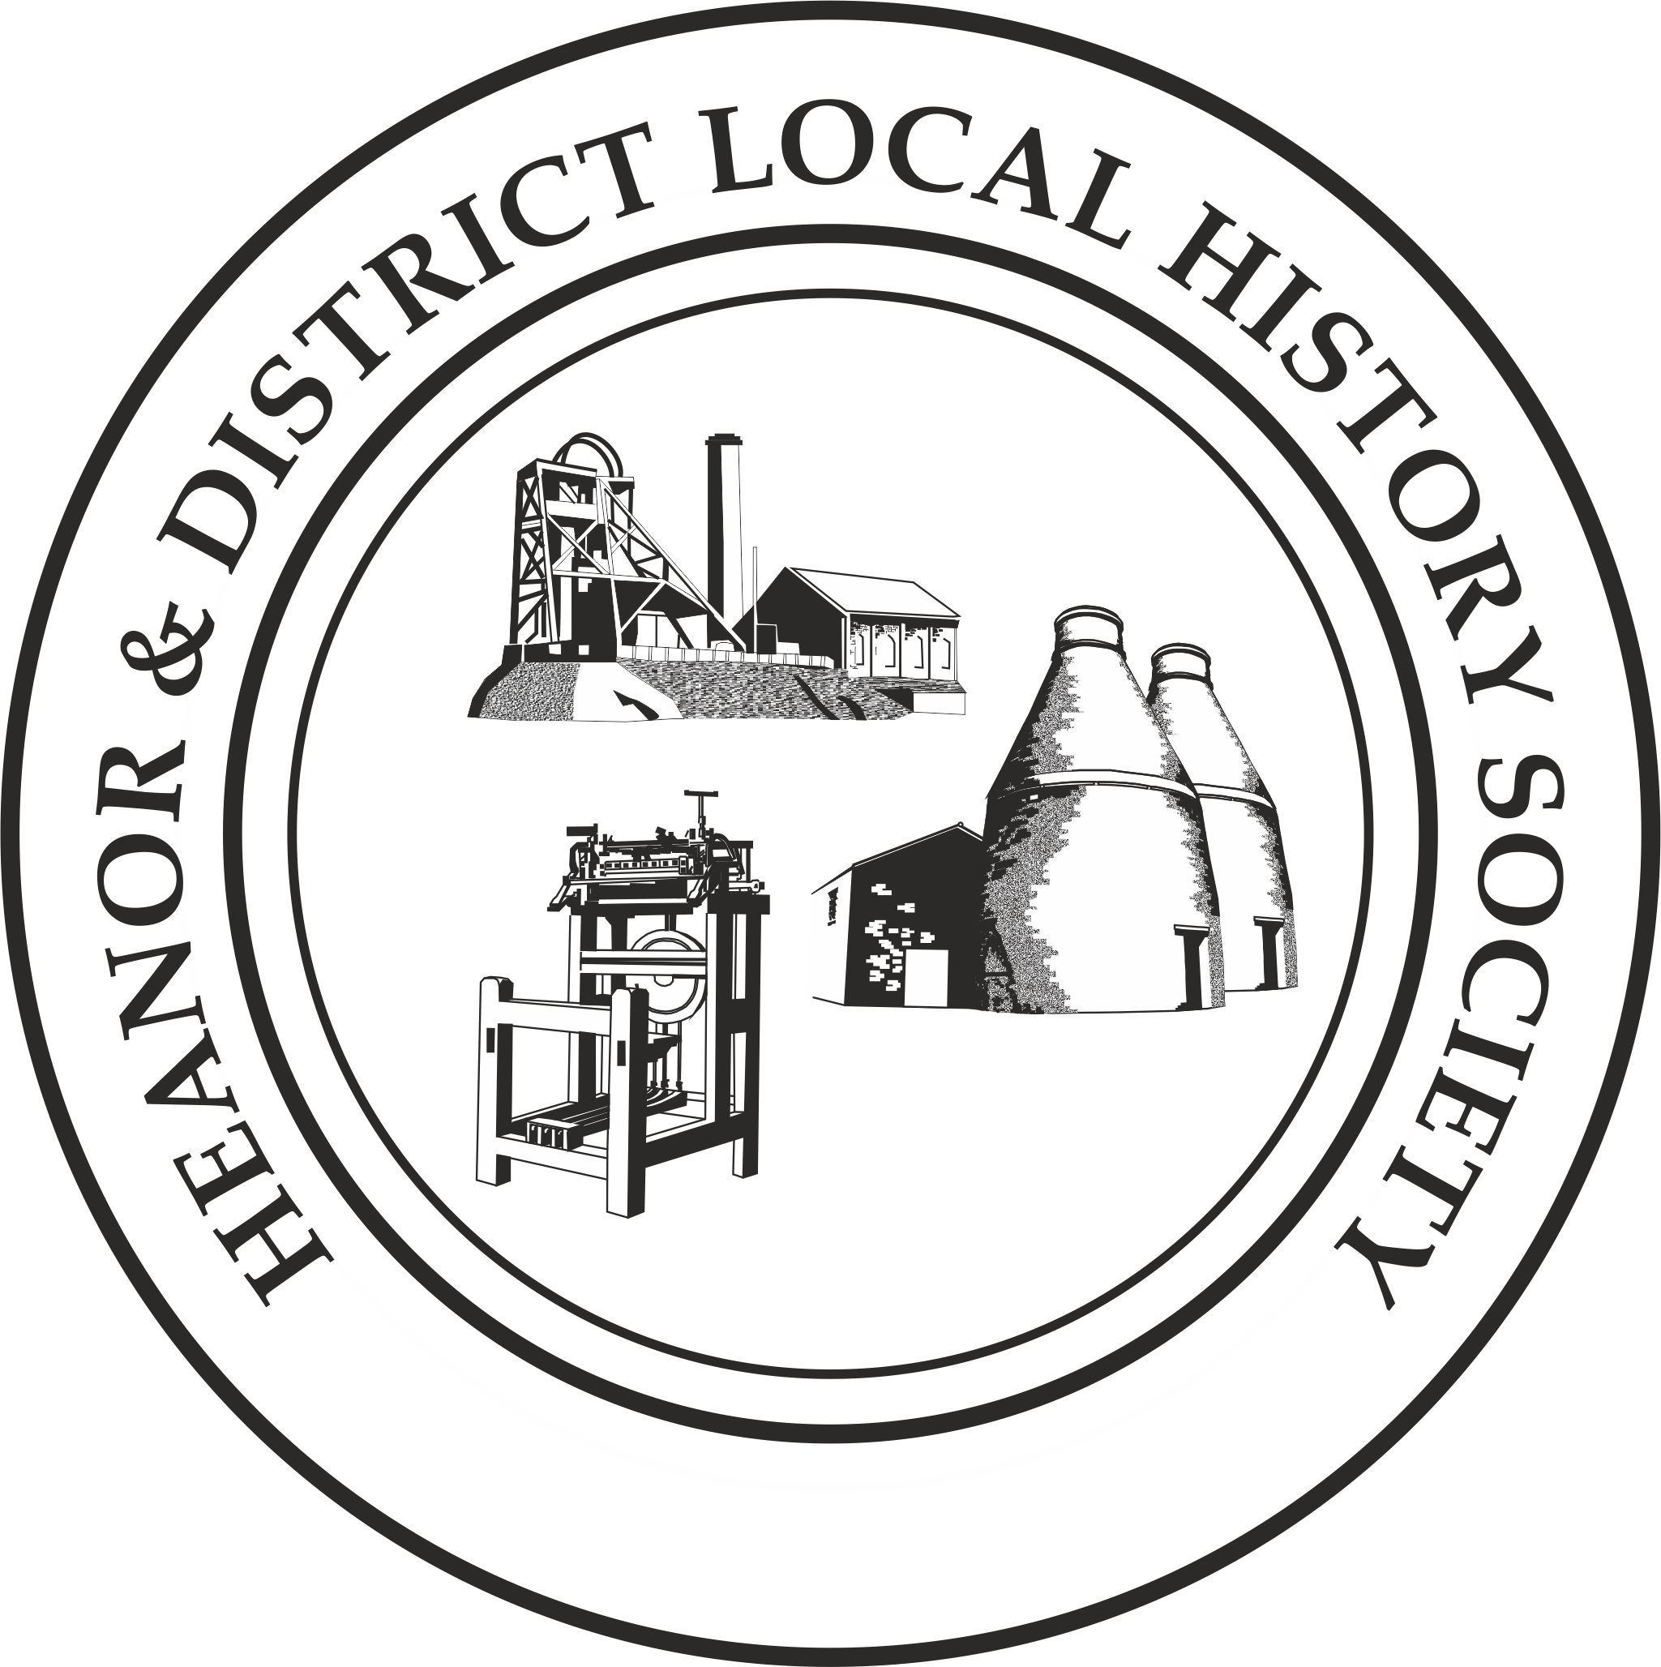We want your memories! As part of an ongoing project, the Heanor & District Local History Society wants to hear from YOU.
We would like to establish a collection of people’s memories about the area - it can be from any period, and from any part of the district. And ANY subject - whether home life, work life, shopping, leisure. It doesn’t matter how trivial you may think your reminiscences are, they will help form part of a much bigger picture, which we can use to assist our future research, publications and newsletters.
This is nothing new of course; we have always asked for this from our members, but have now decided to use this method to try to prompt people to give information on specific issues.
This month’s topic is: Holidays
This time we want to look back to an early holiday, either as a child or young adult. Perhaps the first you remember, with your family, or perhaps your first trip without them. It needn’t have been anything grand – a trip to the seaside, a camping trip to the countryside, or your first package holiday – all would be good. Just tell us what you remember about it.

How to pass the information onto us:
- If you normally attend our meetings, just fill in the form and hand it back at the next meeting.
- If you don’t attend our meetings, then you can send us an email with the information (mail@heanorhistory.org.uk), or post it to the Society at 12 Walton Court, West Hallam, Ilkeston, DE7 6NS.
We would rather that you didn’t send us information anonymously, but nobody’s name will be published unless you have specifically given us permission to do so. In particular, we WILL NOT publish anything which of a personal or potentially sensitive nature.
Name | Address
Telephone
Email address
Are you willing for your name to be linked to any information supplied? |  | Yes / No
Would you be prepared to discuss this or related information further? |  | Yes / No

P.T.O.

We want you to think back to a holiday you remember; try and concentrate on one specific trip – the one where your memories are most vivid.
When was this (decade)?
Where did you go, and for how long? Who went with you?
What can you remember about the lead-up to the trip, e.g. packing?
What transport did you use to get there? Anything eventful about the journey? How long did it take?
Where was your accommodation, and what was it like?
How did you spend the time while you were away? Was there anything which stands out about the place?

Did you bring back any souvenirs of the holiday?
Please use a separate sheet if necessary, or complete another form for a different holiday if you like. Thank you

